Chapter Interlude 2: Pointers, Polymorphism, and Memory Allocation

See also
These CS 200 lectures might help you out…
- Pointers
http://edu.moosader.com/lectures/cs200/16-Pointer.mp4
- Memory management
http://edu.moosader.com/lectures/cs200/17-Memory-Management.mp4
- Dynamic variables & arrays
http://edu.moosader.com/lectures/cs200/18-Dynamic-Arrays.mp4
- Polymorphism
http://edu.moosader.com/lectures/cs200/22-Polymorphism.mp4

Vocabulary
Write out a description of each vocabulary term for reference later.
Term | Description
Early binding
Late binding
Pointer
Polymorphism
Reference
Virtual method

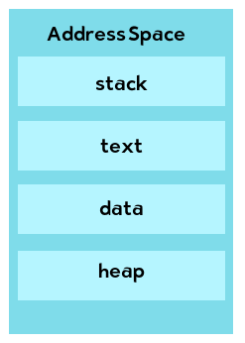
Concepts

Process address space
In general, every time you run a program, it begins a new process. If you run the program multiple times simultaneously, there will be multiple processes of the same program. A process has address space, which includes the stack – a place where local variables’ memory is allocated, the heap – a place where dynamic variables’ memory is allocated, the text – where the program is stored, and the data – where global and static variables’ memory is allocated.
This is the sort of thing you’d learn from a Computer Architecture or Operating Systems class, but it can be handy to know when talking about dynamic memory.
(Note: The book calls the heap the free store, the stack the run-time stack, the data static storage, and the text code storage)

Types of memory errors
There are several types of memory errors that can occur once you’re working with pointers. Using the slides from the Memory Management lecture, describe the following:
Error type | Description
Invalid memory access
Memory leak
Missing allocation
Uninitialized memory access
Dangling pointer

Dynamic memory allocation
You can allocate memory for dynamic arrays and for dynamic variables by using pointers. The syntax is a little different for each of these.
Allocate memory for a dynamic variable:
Free memory for a dynamic variable:
Allocate memory for a dynamic array:
Free memory for a dynamic array:

Polymorphism
You can use polymorphism by taking advantage of class inheritance, pointers, and late-binding via virtual methods. The idea behind polymorphism is that the base class will define some interface that all subclasses will follow. Because they’ll share a common interface, we can treat any of the subclasses as the base class (via a pointer). The program will figure out which subclass’ functions to actually call during run-time, but from the code side, it’s essentially working with pointers to the base class.
Confused? It can take some extra studying to get used to. Make sure to watch the video lecture.

